The report options below will help you determine which families have completed, not completed or started the registration process. This report will also help determine who has an address change and who must attend Document Review. Follow the procedures provided by Student Services to determine who is required to attend Document Review.
Begin in Student Management  Click: Student  Click: Online Enrolllment (OE)  Click: Reports (RE) | 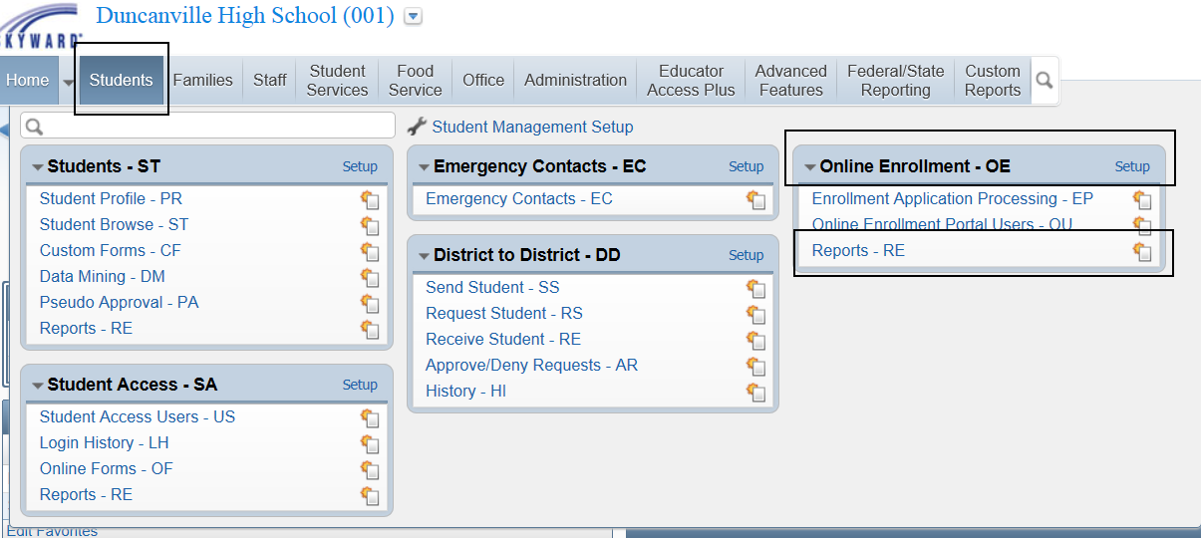
Under Reports Click: User Defined Online Enrollment Report  Click: Add | 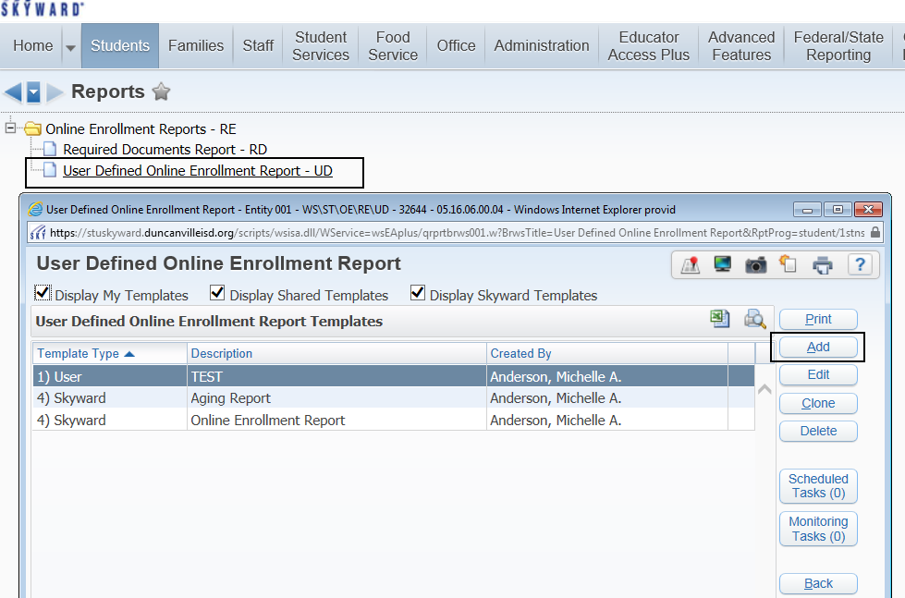
Name Your Template:  Student Ranges:  Select appropriate student ranges. You may want to leave these ranges set to default.  Application Ranges:  Choose: Date Received, Date Approved. To pull data regarding specific Application Status Click: Statuses and select appropriate Application Status. Click: Save | 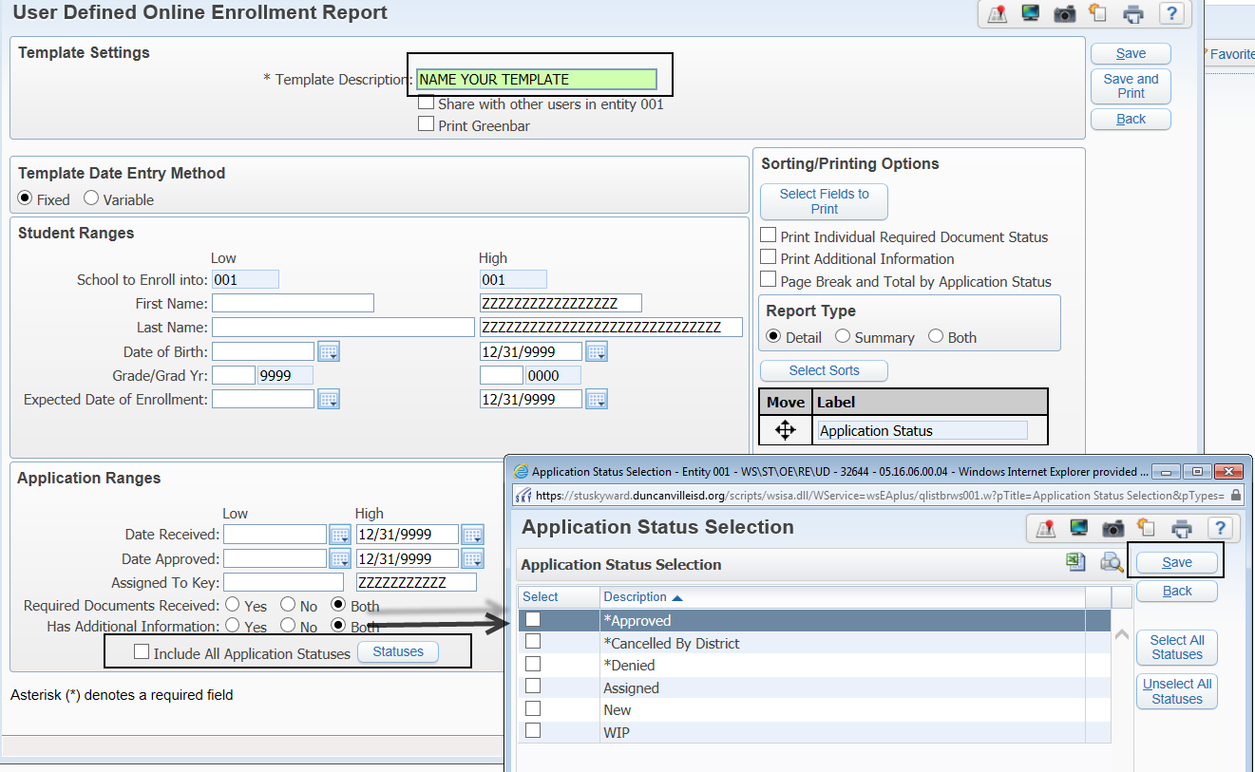
Click: 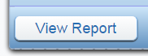or  Click:  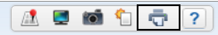  Click: View or Convert to Excel | 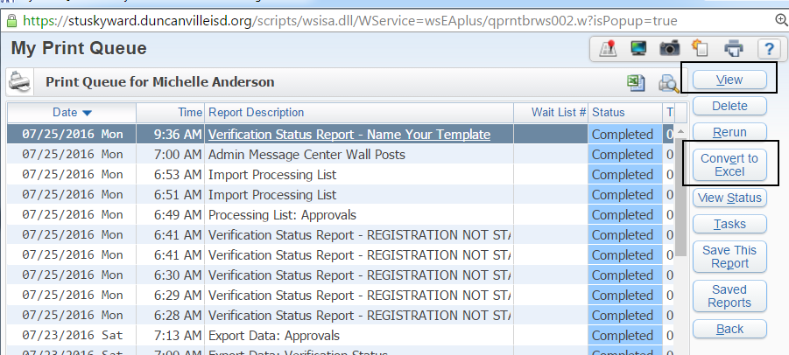
If converting to Excel select the following prompts that best fit your needs. | 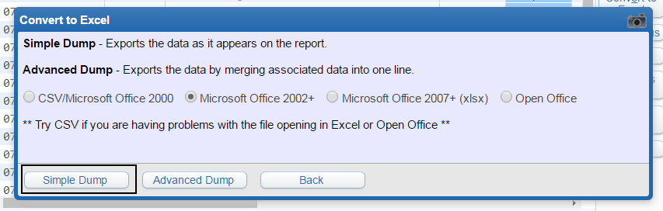
The file is sent to the Print Queue where you can Click Display Report | 