The report options below will help you determine which families have completed, not completed or started the registration process. This report will also help determine who has an address change and who must attend Document Review. Follow the procedures provided by Student Services to determine who is required to attend Document Review.
Begin in Student Management  Click: Student Management  Click: Families (FA)  Click: Family Access (FM)  Click: Online Registration (OR)  Click: Reports (RE) | 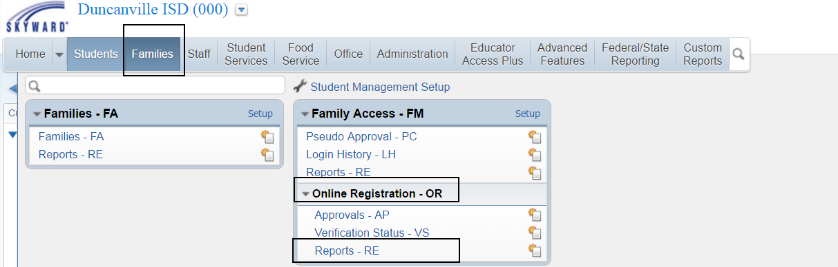
Click: Verification Status Report  Click: Add | 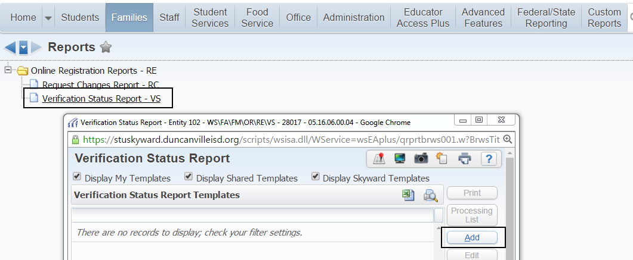
Name Your Template:  Report Ranges:  Select School Year  Student Selection:  Choose: Verification Status, Individual or Processing List  Verification Status:  More than one option can be selected or you can create a template for each option separately.  To select a list of student that haven’t started the registration process  Click: Show Not Verified and Only Students where Online Registration has not been started  Fields to Print:  Select the fields you want displayed on the report. | 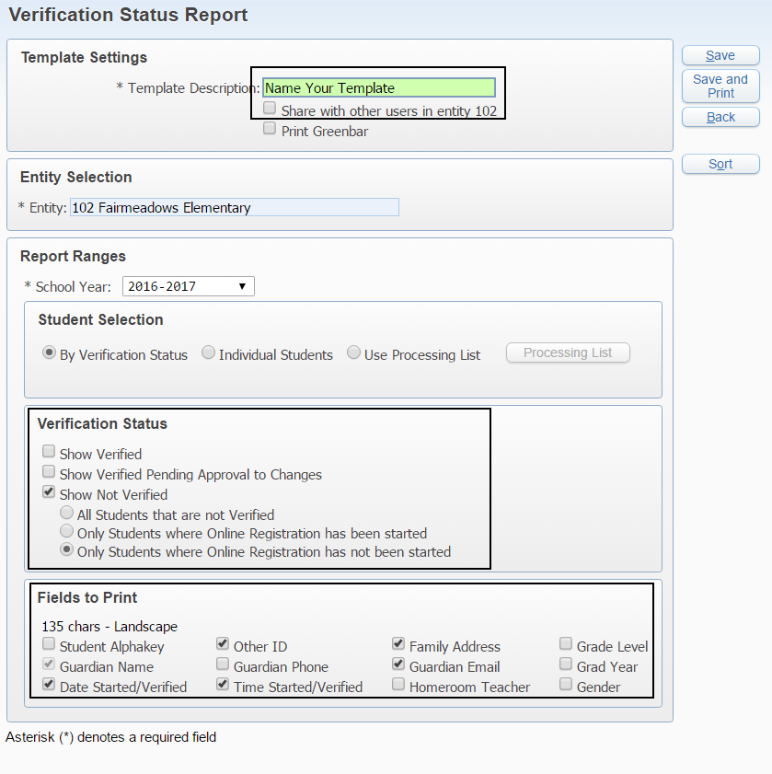
Once the template is set up according to your needs  Click: Save and Print | 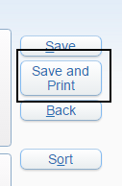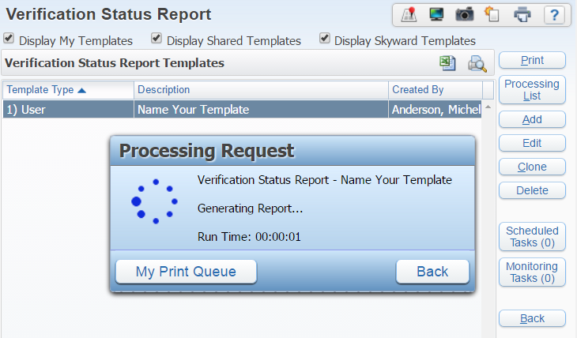
Click: 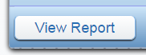or  Click:  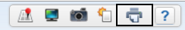  Click: View or Convert to Excel | 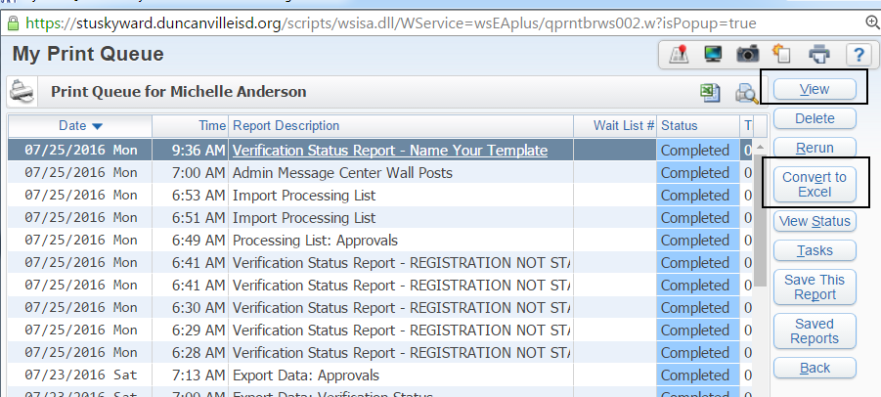
If converting to Excel select the following prompts that best fit your needs. | 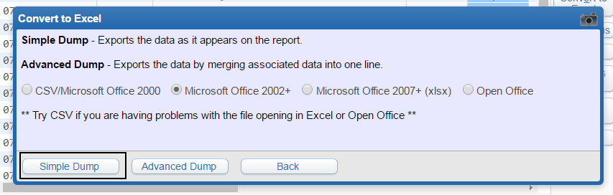
The file is sent to the Print Queue where you can Click Display Report | 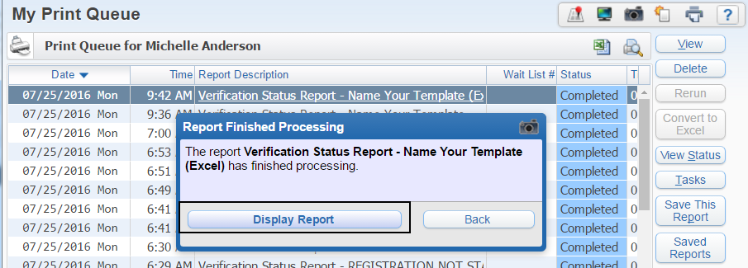
REQUEST CHANGE REPORT:  Run this report to see if there are any address changes that will require a family to attend Document Review. | 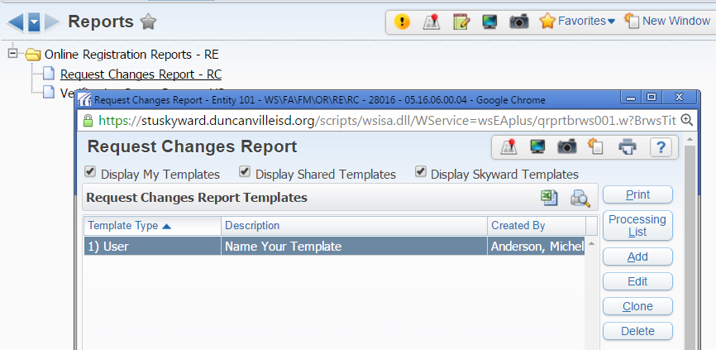
Template Settings:  Report Ranges:  Select date ranges  Report Options:  Select the options you need information on. | 