Follow these steps to determine enrollment counts for a specific day
Begin in Student Management  Click: Office (OF)  Click: Attendance (AT)  Click: Reports (RE)  Click: Enrollment Report (ER) | 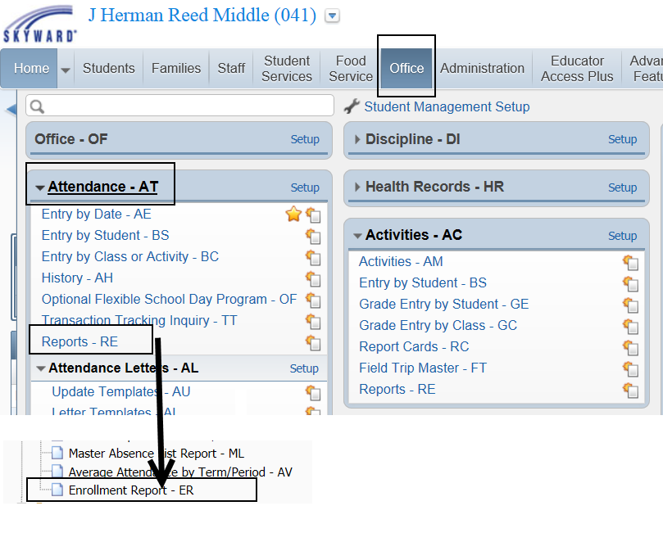
Click: Add  Template Settings:  Name Template  Report Ranges:  Student Key: Default  Grade/Grad Yr: Default  Select Enrollment Date  Include All Calendars and Include All Schools  Printing Options:  Select Printing Options.  To view all student names select Print Student Detail. If you just need an enrollment count, uncheck it.  Save and Print | 