Three Types of Schedule Changes

- Section Changes within the 1st Semester for a YR/SM Course – this type of schedule change is used when needing to change a student from one section of a course to another section of the same course during the 1st semester of the school year (before a SM grade is posted)

Highlight the course that needs to be changed and click on the Chng Section button

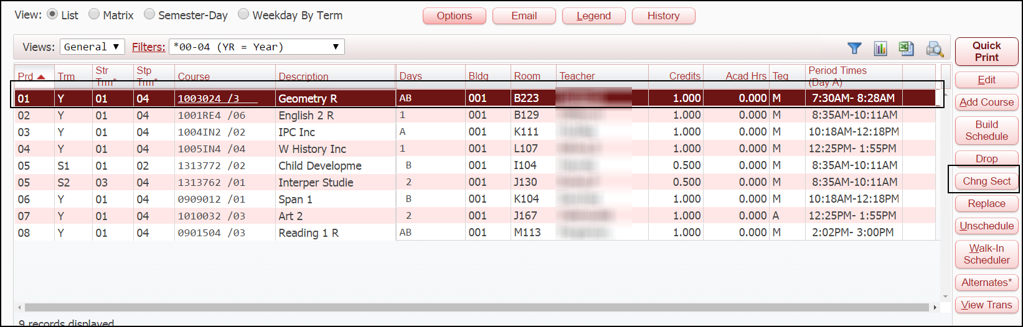

At the bottom of the screen, highlight the new section to be selected and click on Schedule Class
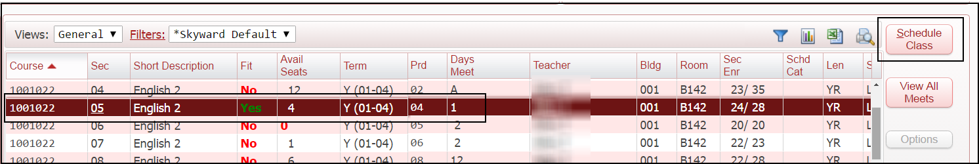

On the next screen you need to enter the Effective Dates as the date in which the student began attending the new section of the class and put a check mark in the box that says Move Attendance and then click Continue

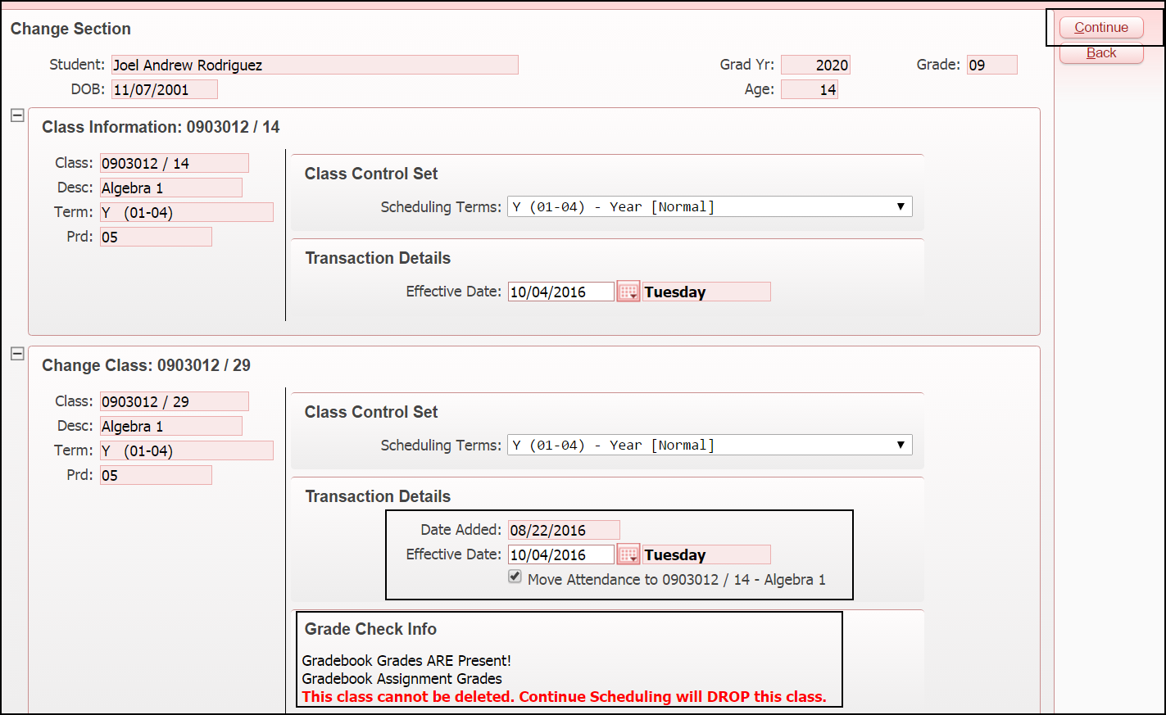

- Term Adjustments at the End of the Semester – This type of schedule change is used for when a student finishes the first semester of a yearlong course and needs to be moved to another period/teacher of the same course for the 2nd semester (this is done so that the SM1 grade is not duplicated for this class)
Highlight the YR course that needs to be adjusted and click Edit

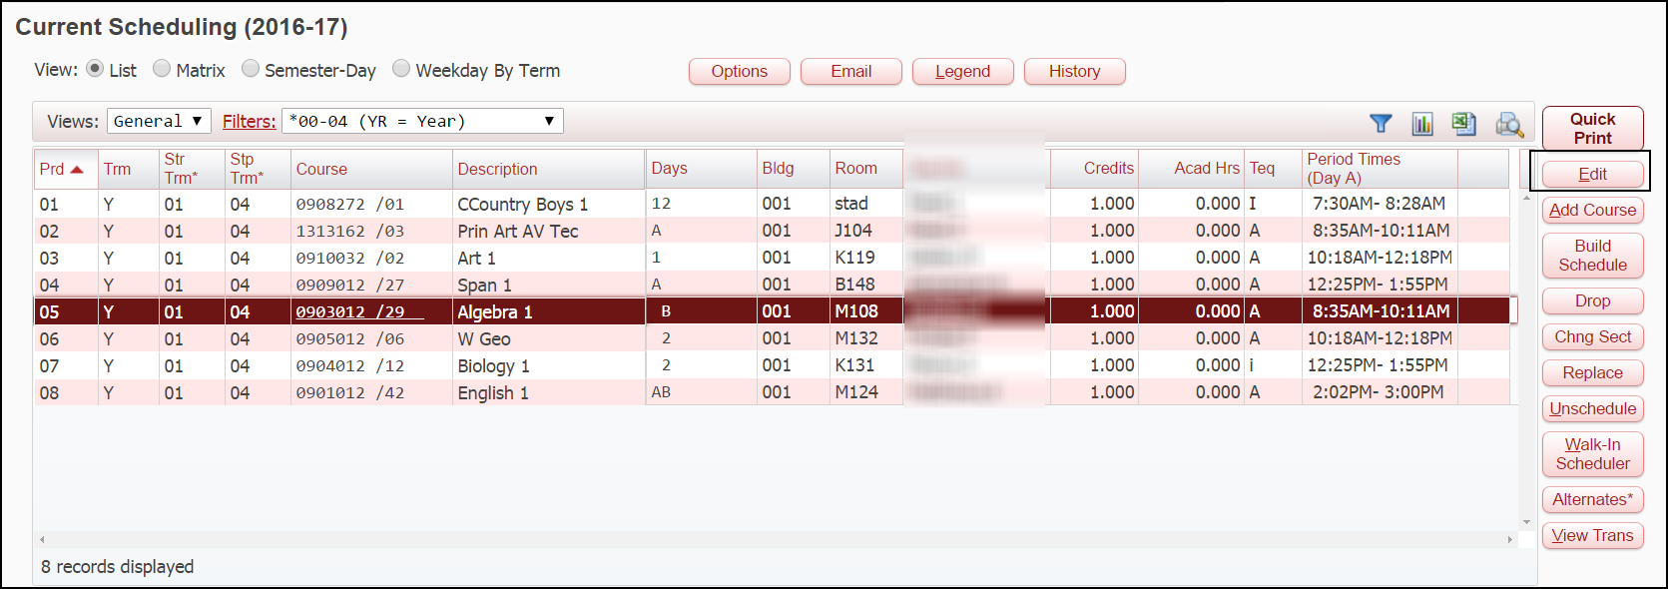

A message box will pop up – Click Change Terms

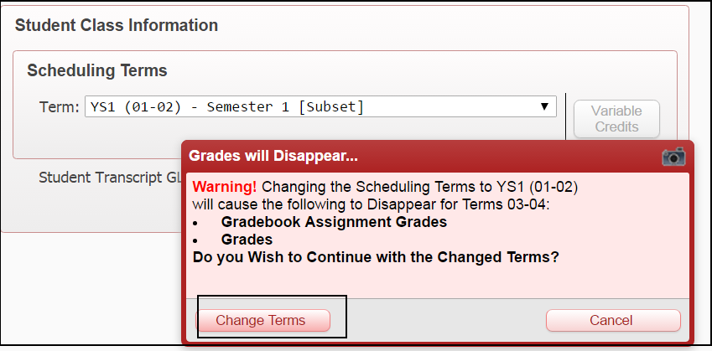
The effective date has to be the LAST day of the 1st Semester – Click Save

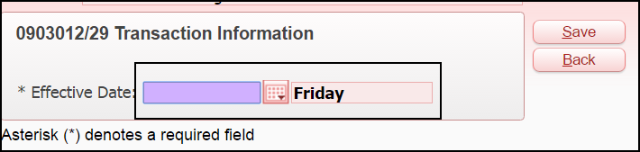
Now you need to add the 2nd semester portion of that class – Click Add Course

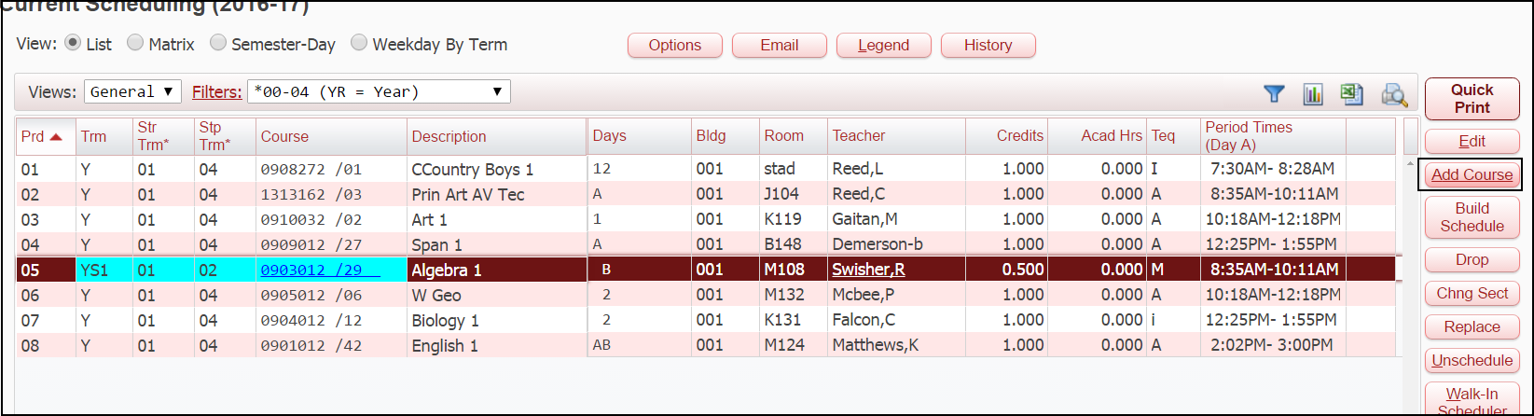
Type in the name of the course and find the new period/teacher that is needed and click Schedule Class
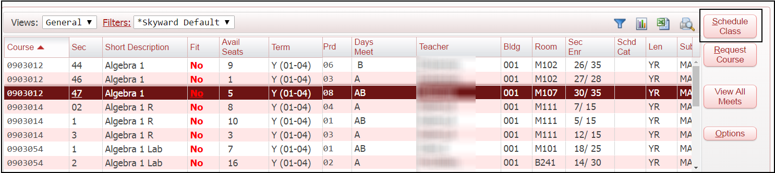

Under Scheduling Terms – Change to YS2 and the Effective Date Must be the first day of the 2nd Semester. For the 2016-2017 SY the effective date will be 1/4/2017. Click Continue
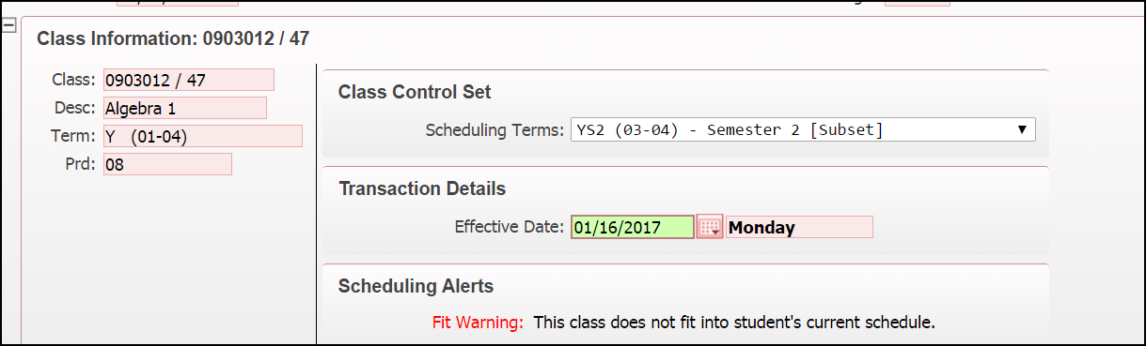

- Changes During the 2nd Semester – There are two types of changes that can be made during 2nd semester depending on the situation.

A student in a yearlong course needs to change to another period/teacher after the beginning of the 2nd semester (during the 3rd nine weeks or later)

DO NOT term adjust the Yearlong Course – You are going to DROP the Yearlong Course

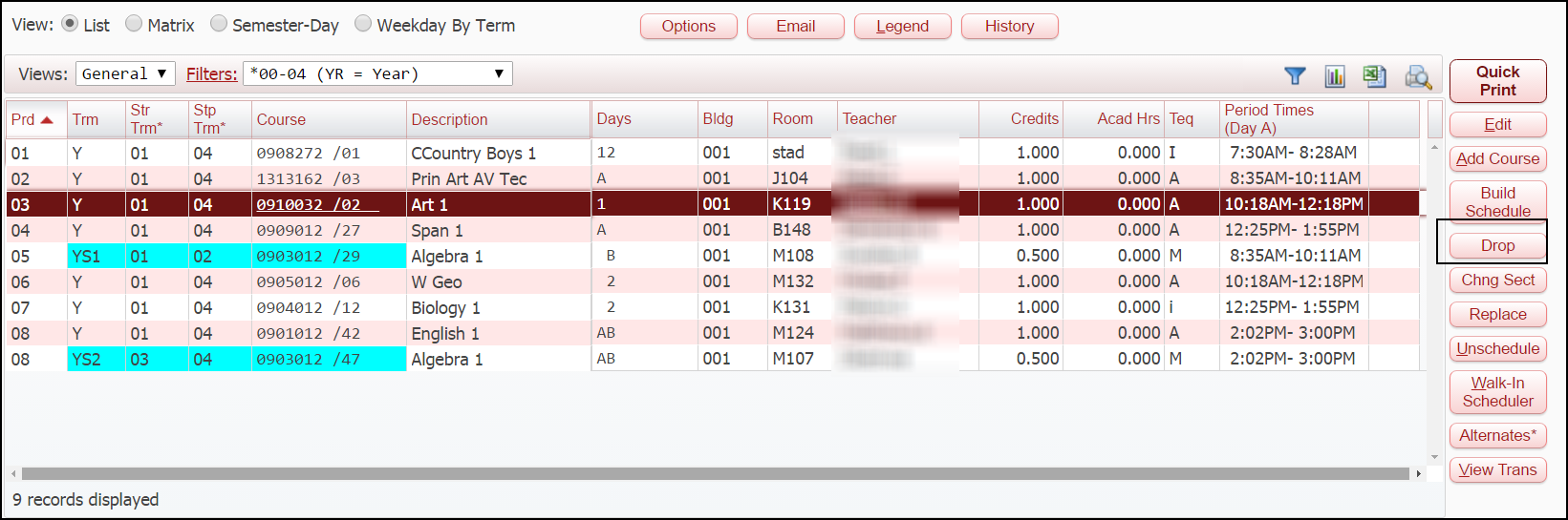

Message Box pops up – Click Drop
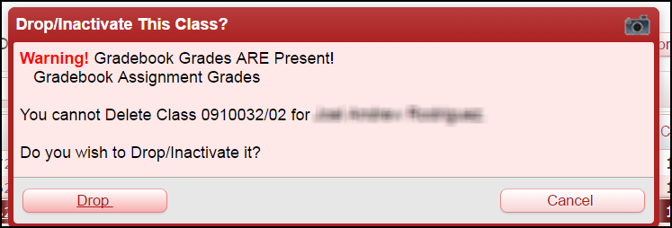
The effective date should be the last day the student attended this class – Click Save

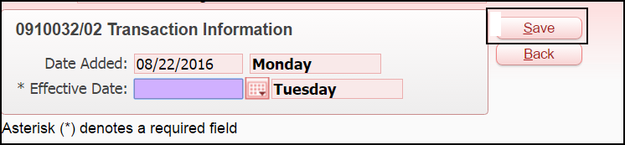

Now you are going to ADD the new section of the course for S2Y only.

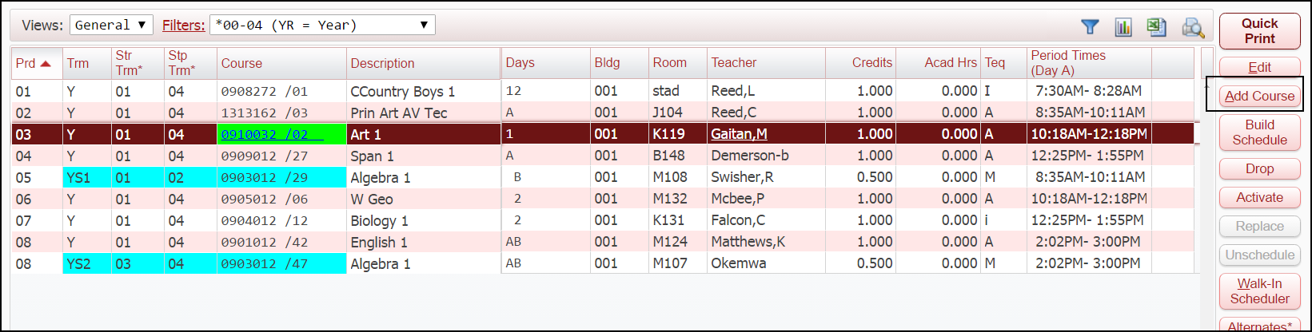

Find the course/section/teacher that is needed and click Schedule Class

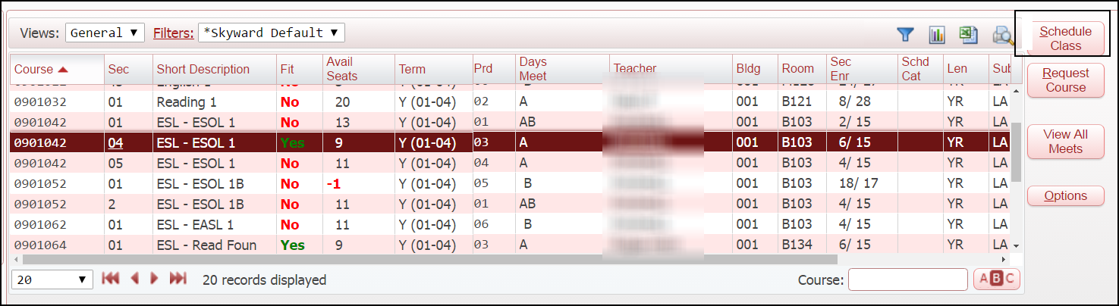

Under Scheduling Terms – Change to YS2 and the Effective Date should be the day the student started in this class – Click Continue
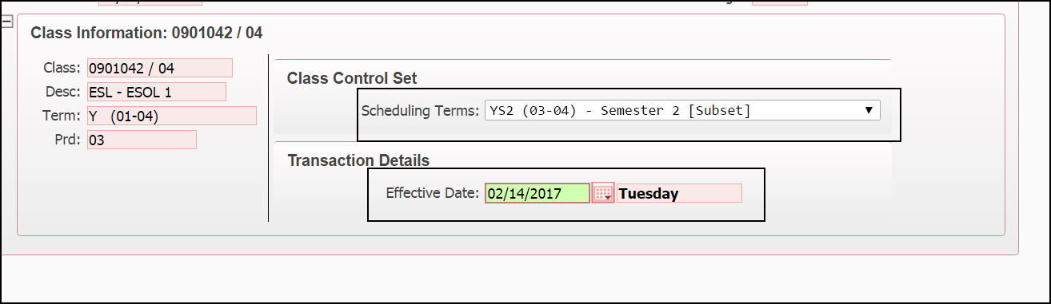

B. Student in a YS2 class needs to be moved to another period/teacher for YS2 (during the 2nd semester)

Highlight the YS2 class that needs to be changed and click on Chng Sect

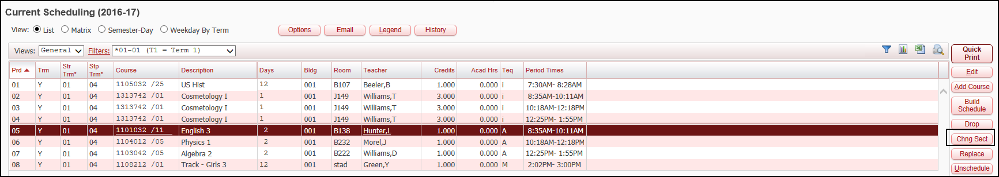

Find the new period/teacher that is needed and click on Schedule Class
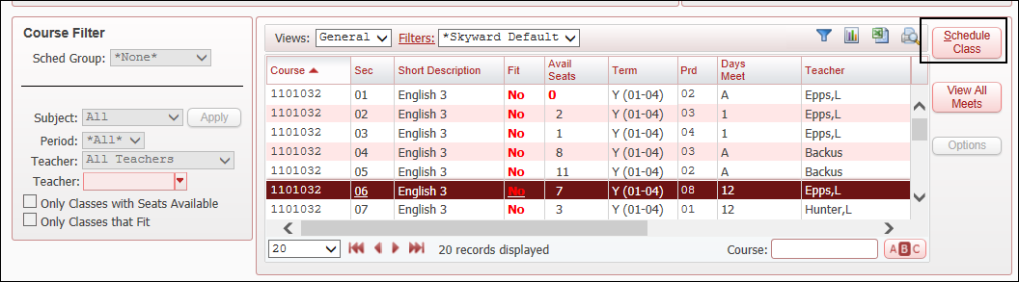

Under Scheduling Terms change to YS2 – The Effective Dates must be the date the student started in the new class – Also put a check mark in the box to Move Attendance – Click Continue

