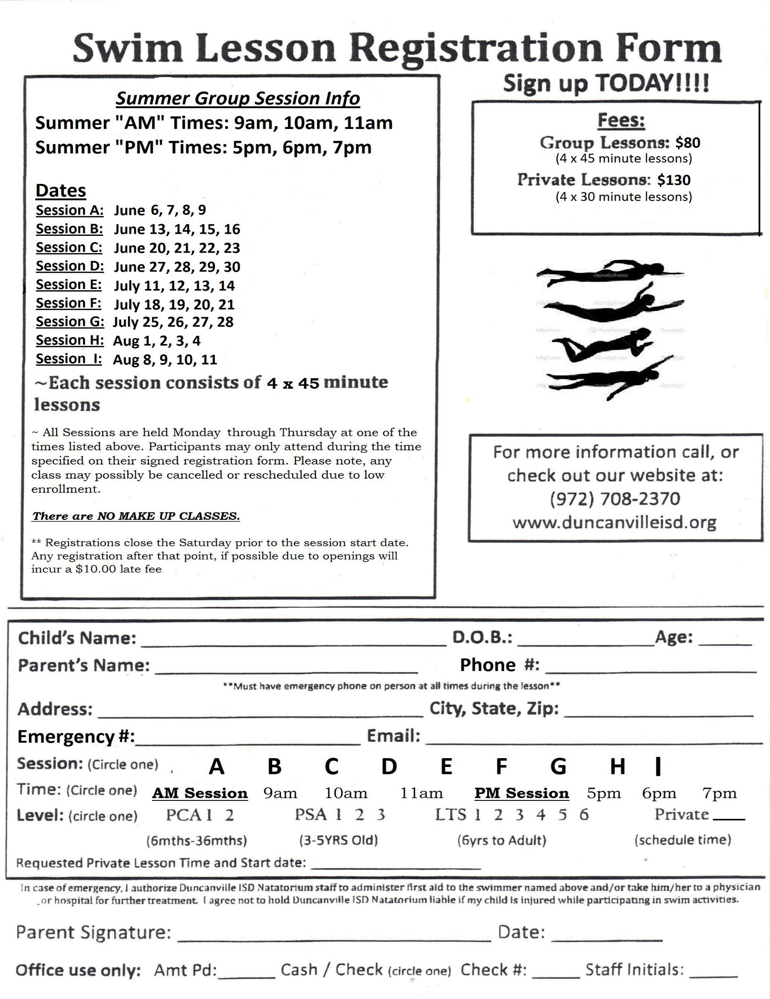

**Summer Group Lesson Dates & Times AM Times: 9 am or 10 am PM Times: 5 pm or 6 pm**

**5 pm 6 pm**

**9 am 10 am OR PPMPM pm7PM**

**A B C D E F G H**

**~ Summer group lessons are held Mondays through Thursdays at one of the times listed above, participants may only attend during the time specified on their signed registration form. Please note, any class may possibly be cancelled or rescheduled due to low enrollments. There are no refunds after you attend the first lesson.**

**Summer Dates:**

**Session A June 3, 4, 5, 6**

**Session B June 10, 11, 12, 13**

**Session C June 17, 18, 19, 20**

**Session D June 24, 25, 26, 27**

**Session E July 8, 9, 10, 11**

**Session F July 15, 16, 17, 18**

**Session G July 22, 23, 24, 25**

**Session H July 29, 30, 31, Aug 1**

**$130**

**$80**