HOW TO FULFILL A RECORDS REQUEST
FROM A TEXAS PUBLIC SCHOOL
- Select Manage Records/Transcripts
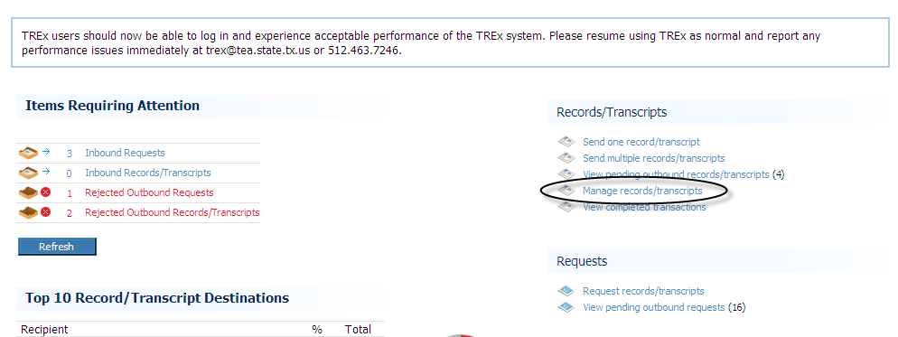
- Select Create
- Enter required information (*)
When done entering required information select “Save” and then “Next”
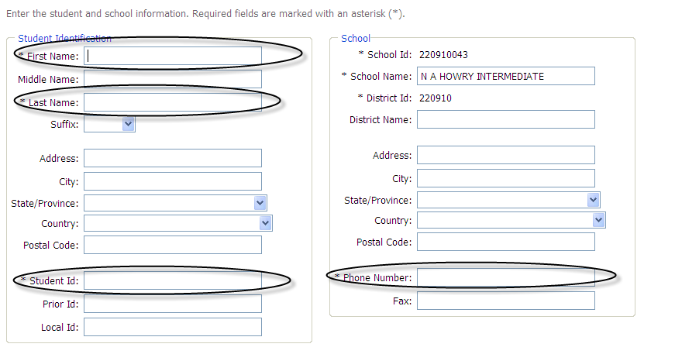
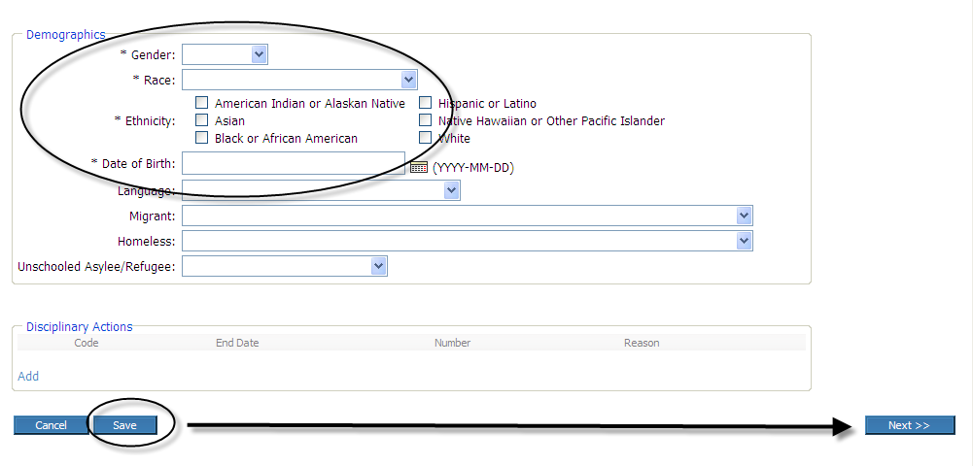

- Enter remaining required information.
Select “Save” and then “Next”
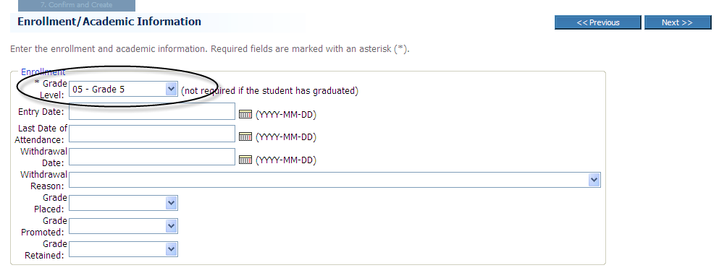
- Select the Validate tab
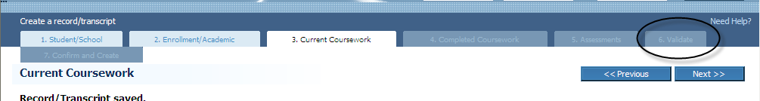
- Validate your file (data file)
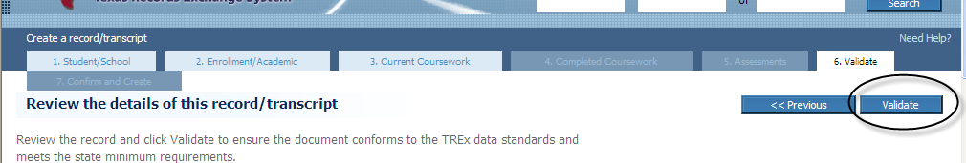
- Validation Results will tell you your data file was created with warnings.
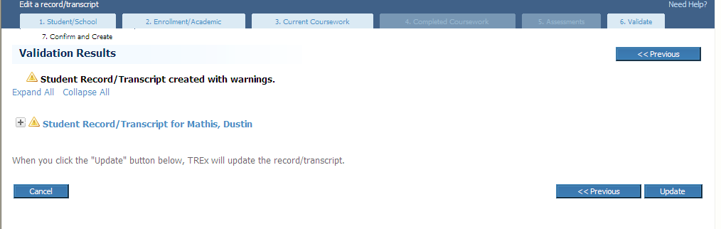
- Go back to the Home Page

- Manage Records/Transcripts
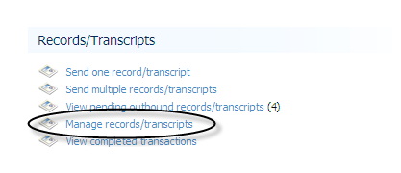
- Select the file you just created and “Add attachment”
Browse to find your .pdf file (the b/c, SS card, report cards, etc.) and Upload
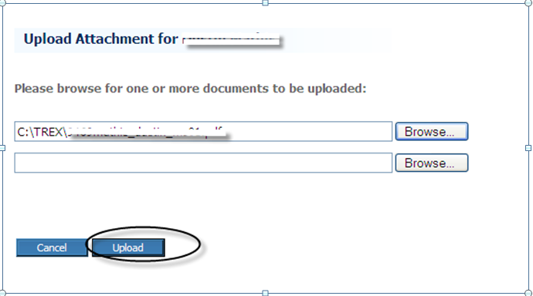
- Go back to the Home Page
- Select Send one record/transcript
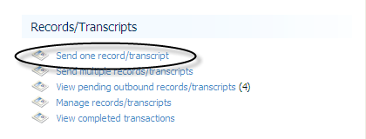
- Select the record you are sending and “Next”
- Search for Institutions/Select/Next
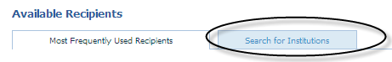
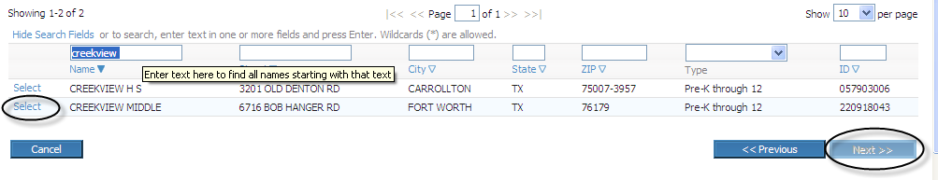
- Enter Comments and Send
