This report provides Action or Offense counts for students in Special Programs.
In Student Management Click: Office  Click: Discipline  Click: Reports  Highlight: Discipline Counts report  Click: Edit | 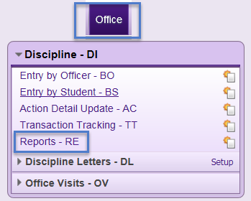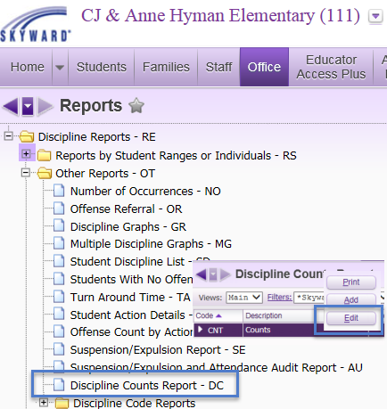
Student Ranges  Grade: Blank or grade range  Current Year Status: Active/Inactive Students  Click: Save  Expand: CNT  Click: Edit | 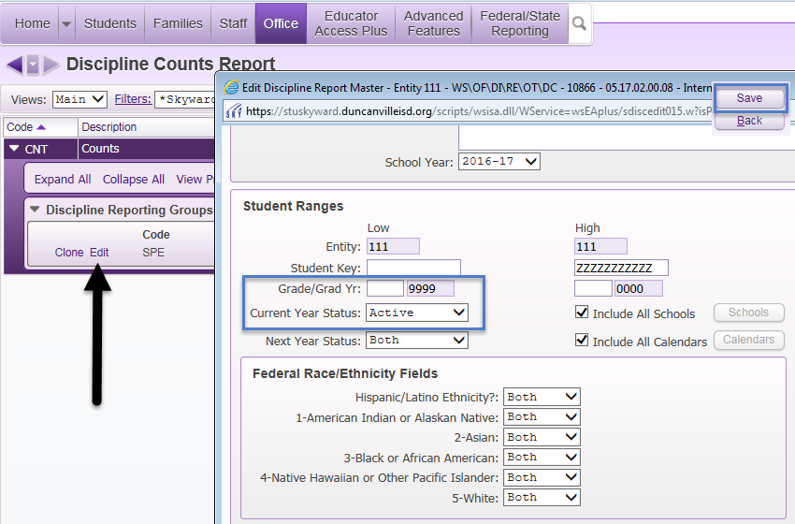
Report Options  Calculate Counts Using: Select Offense or Actions  Offense Options:  Record Type: Offense and Referrals or select appropriate options  Action Options:  Click: All Actions. To select specific actions Uncheck the box and select specific Actions  Student Options:  Click: Only Special Ed  Grade Buckets to Use: Select desired Grade Buckets  Click: Sort By | 