Follow the steps below to process a NSOE Application.
Student Management Students (ST)  Online Enrollment (OE)  Enrollment Application Processing (EP) | 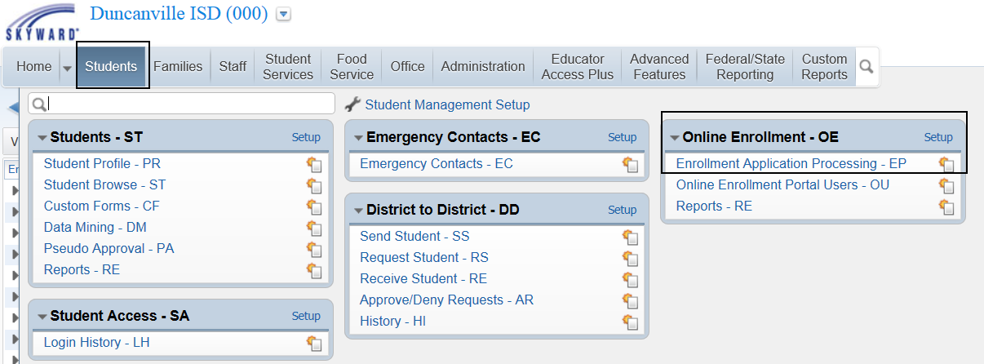
Highlight and Expand the NSOE and verify the address is assigned to the correct campus.  You may also want to verify the Relationship to Child in this step. | 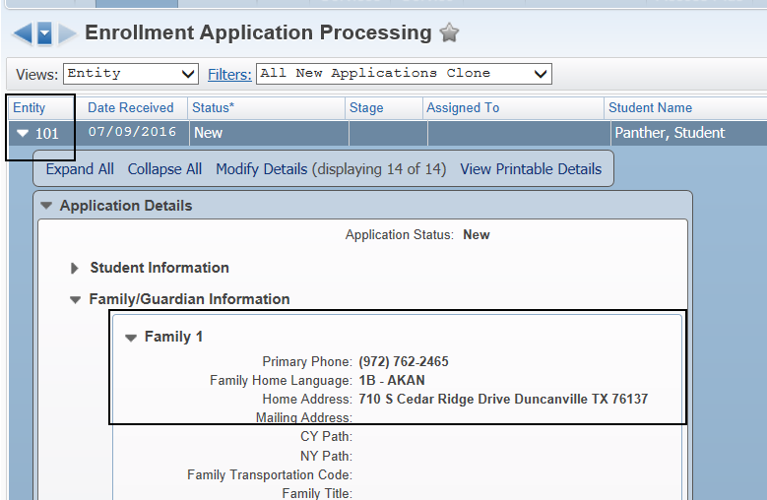
Click Process Application Click Yes to begin processing the application and Click Yes to assign the application to yourself. | 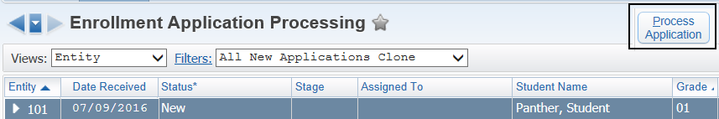  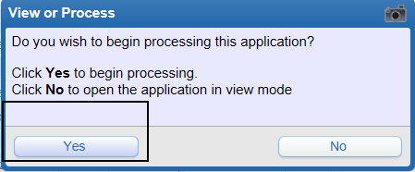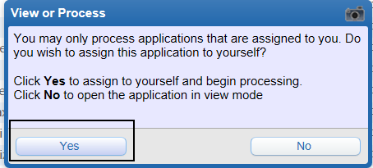
VERY IMPORTANT!  Match the Names for the student to the database to see if there is already a student record in the system. | 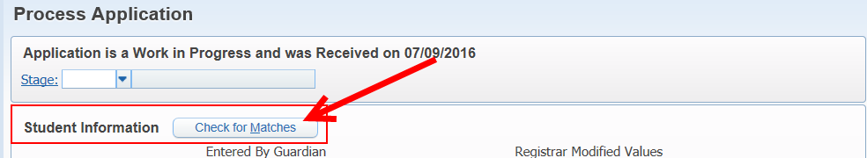
The system will return any matches. If there is a return verify to see if this is a NEW student name added to the database or if this student already has information. If the student is not found in Skyward Click: Back. If there is a match Click: Select Name as Match | 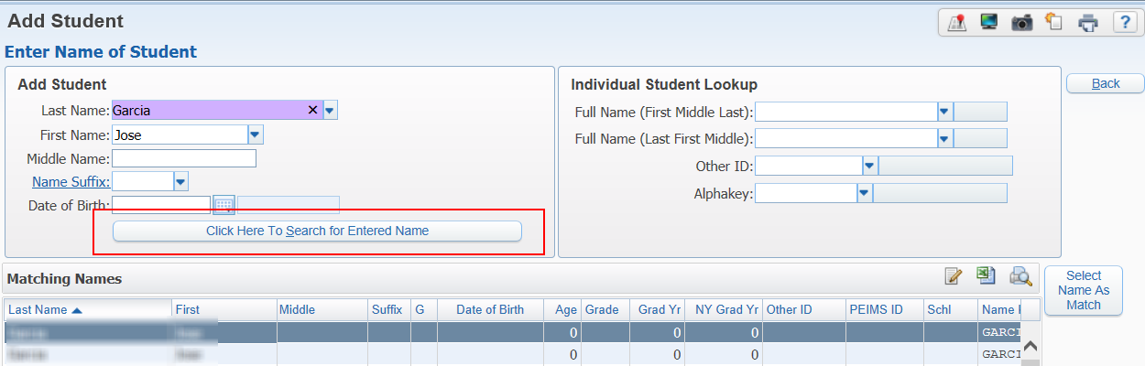
Student Information  Review the information entered and make changes if needed.  The information in the left column was entered by the family. The information in the right column will be entered into Skyward once completed. | 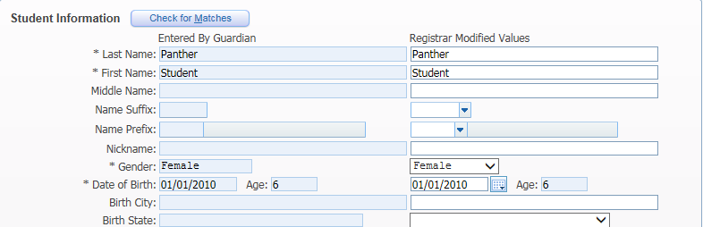
Additional Demographic Information  Other ID: Number will increment once the application has been accepted.  Full/Part-time: Full-time  Current Year Status: Active  Unique ID: Enter 10-digit if available  Next Year Status: Active  Current Year Member: Yes  Include in Honor Roll: Yes  Include in Rank: Yes | 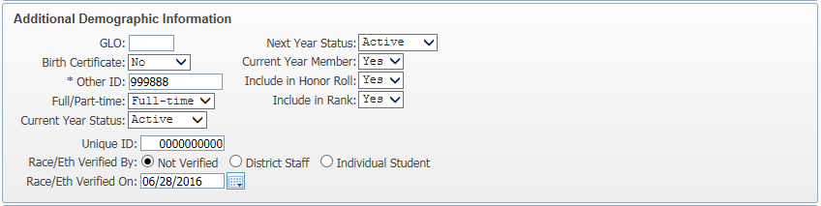
Enrollment Information  Entry Code: This is the ADA Eligibility Code: Most students will be a “1” if they meet 240 minutes of instruction.  Percent Enrolled: 100  School: Select school the student will be attending.  Calendar: Is the same code as the school code.  Student Type: Most students will be REG unless they are a transferred student. If this is a transfer student use the appropriate transfer code. DO NOT use SPE.  Resident District: 057907  ENTRY CODE NOTE: Passing period and lunch DOES NOT count. | 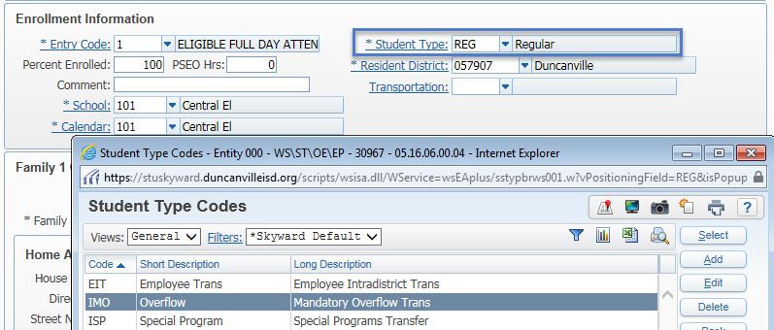  Entry Code: Examples; not an exhausted list. See SAAH or contact PEIMS department.  1 – Full-time enrollment. This student is instructed for at least 240 minutes each day.  This will be most of our students.  2 – Part-time enrollment. This student is instructed for at least 120 minutes each day.  This will be most of our PK students and it could be students that have early or late  release. Count the number of minutes they are being instructed each day.  3 – Full-time transfer student. This student is instructed for at least 240 minutes each day.  Students that DO NOT live within our district boundaries AND is an approved transfer.  (Ex: teacher students, LOE, etc.)  4 – Full-time ineligible. Student attends at least 240 minutes but is ineligible for ADA funding.  Student is in our district but not approved district transfer, mandatory JJAEP.  5 – Part-time ineligible. Student attends at least 120 minutes but is ineligible for ADA funding. Same criteria as above.  6 – Part-time transfer student. This student is instructed for at least 120 minutes each day.  Students that DO NOT live within our district boundaries AND is an approved transfer
Match the Names of the Parents to the database to see if there is already a parent/guardian or family from a prior enrollment or older student. | 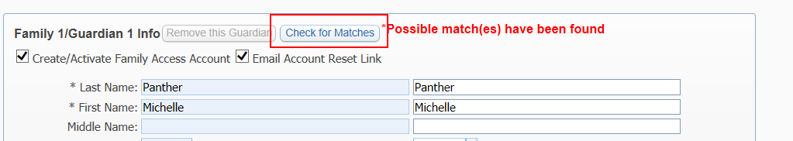
The system will return any matches. If there is a return verify to see if this is a NEW name to be added to the database or if the parent/guardian is already been added into the system. | 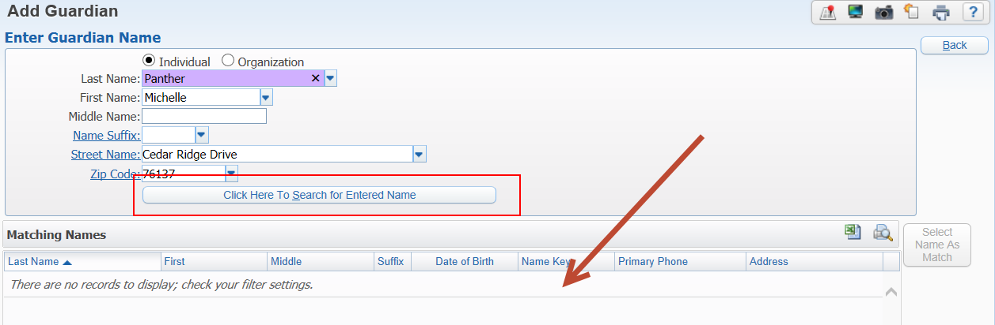
Match the address to our database. Be sure you select the address that we have in the database matching exactly. Do not attempt to overwrite the database with the address input as the parent put it in because it may not match our street guide. This will cause the student to appear to be out of zone. | 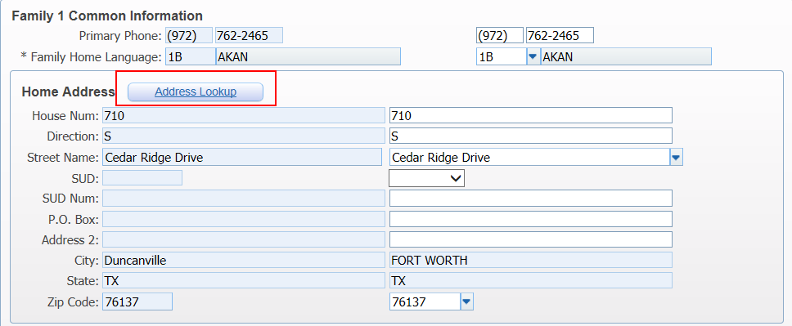
Match the Emergency Contacts as much as you can.  Update any data that needs correcting through the rest of the application. | 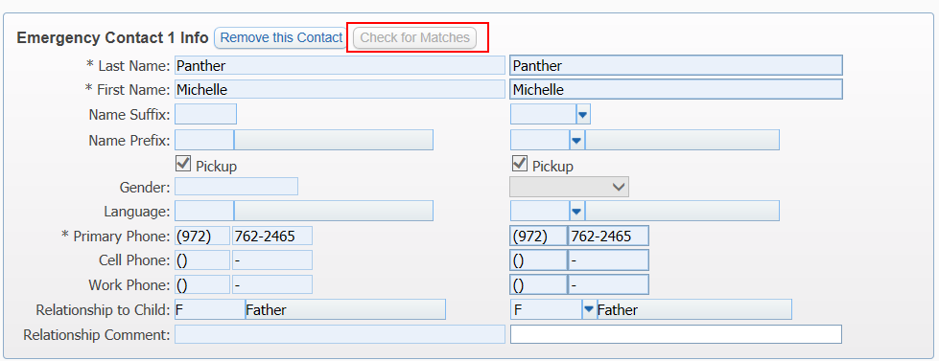
Click: Manage Required Documents.  Families have the ability to load documents needed for registration. Check to see if documents have been attached and Click: Received if they are accepted. | 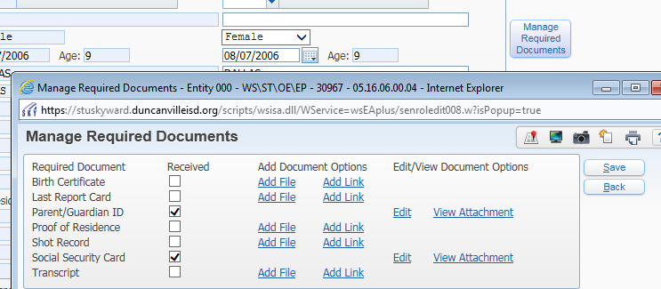
Once you are done reviewing the application and everything looks correct, it is important you complete the next four steps in order.  Click: Deny Application | 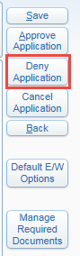
Copy and Paste the appropriate message you need to communicate to the parents.  See attached District-Defined messages.  Click: Continue  An email will be sent to the email on file. | 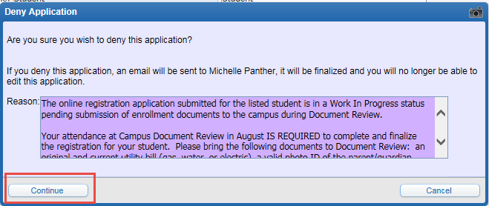
IMMEDIATELY RETURN THE APPLICATION TO WIP | 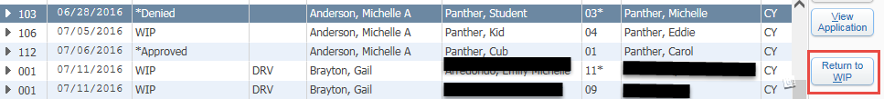
Click: Yes  Click: Process Application and Prepare to Stage the Application according to the previous sent email. | 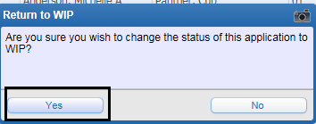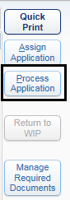
Once you have DENIED, SENT EMAIL, RETURN TO WIP, and you are now in PROCESS APPLICATION, it is time to STAGE the application according to the email that was just sent.  All applications must be STAGED appropriately. To do this Click Stage; Select the appropriate Stage Category and Click Save. | 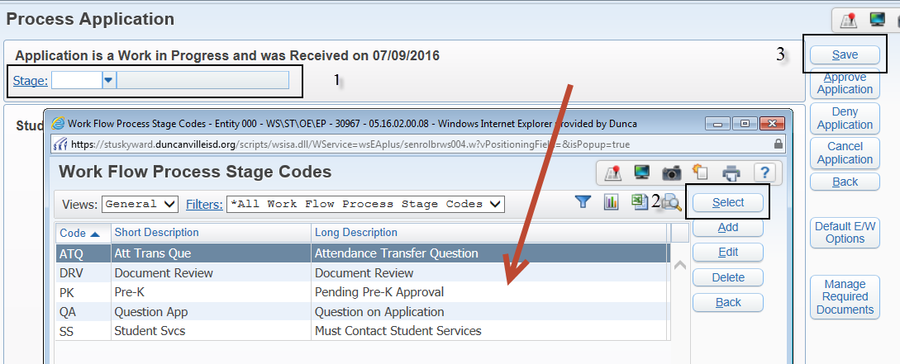
Staging an Application. Most applications will probably go to DRV noting the family only needs to attend document review in August. | ATQ – There is a question about attendance zone meaning the address is not in district or assigned to the wrong campus.  DRV - The application is ready for Document Review  DNL – Application is in Final Denial Stage. This application will be deleted from Skyward permanently.  PK – The student has not been confirmed to be PK eligible (PK registration is August 1 & 2)  QA – There is a question on the application and this application is not ready for document review.  SS – The parent/guardian must contact Student Services before attending Document Review
After you have Staged the application, Expand the Communication Log and document that you have sent correspondence and what letter you have sent to the family.  Click Save | 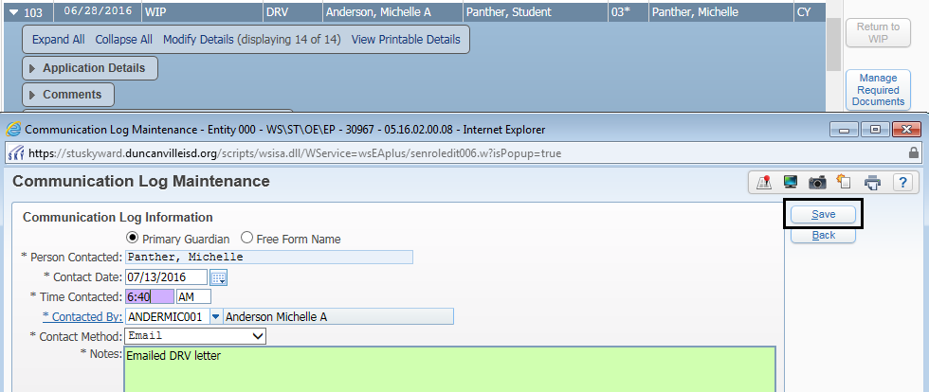
 | AFTER DOCUMENT REVIEW
Highlight the student and Click: 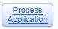
Make any new changes if needed. If all information is correct Click: Approve Application | 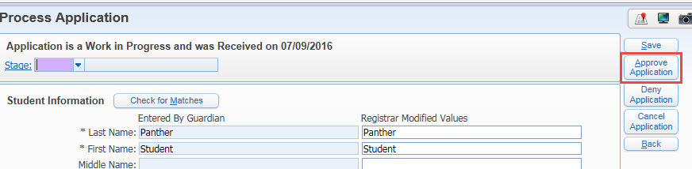
Click: Continue or go back and verify there were no documents to be received. | 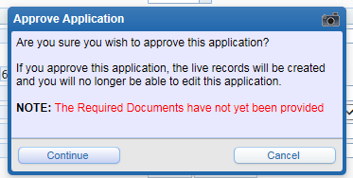
If any required information is missing you will receive an error message. | 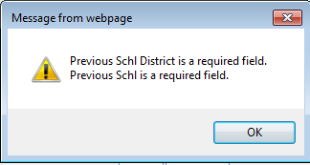
Review every pop up that appears. This message is assigning the student an OTHER ID Click: OK  Other messages you may see are address messages telling you another family lives at this address. | 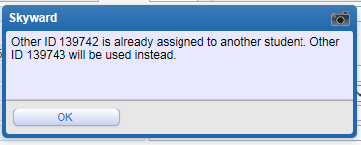
Continue reading the messages and make changes as needed. Once the student is successfully in the system you will receive a message. | 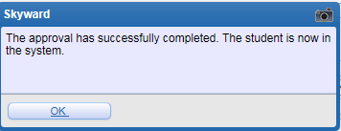
LAST STEP: Go back to Students/Profile and Click: Edit  District Entry Date: Enter the first date the student began school in DISD. The district will use this field to track when students entered DISD.  If student is enrolled Provisionally, you can check this box. Enter the reason in Mom’s Maiden.  Notify staff | 